1. Are the HTML tags and elements the same thing?

* The HTML tags and elements are not same things.
* Tags are used to hold html elements and elements are used to hold content.

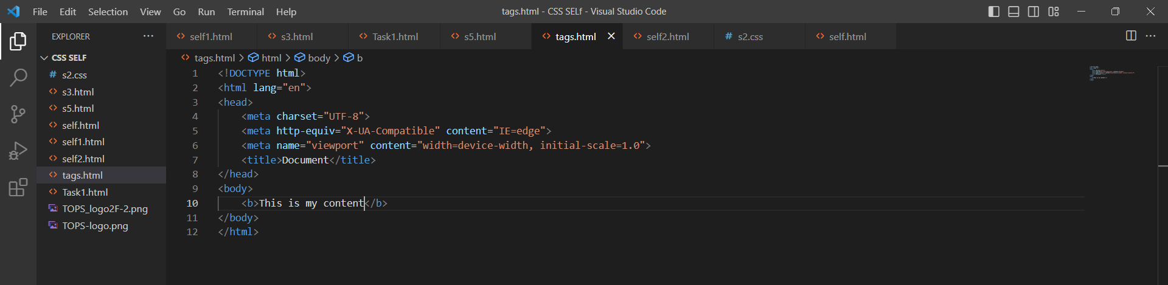

1. What are tags and attributes in HTML?

* Attributes provide additional information about elements.
* Tags are used to hold html elements.

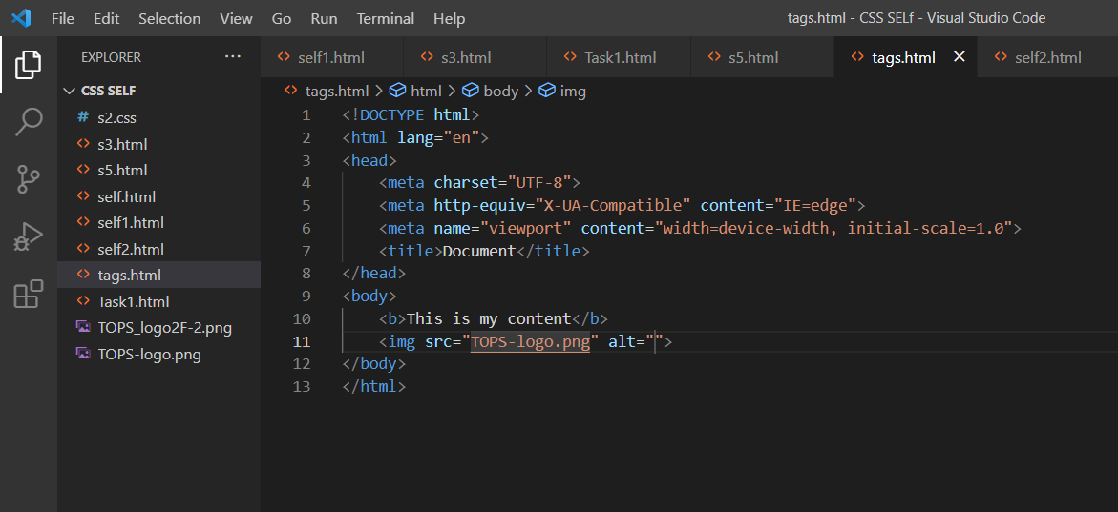

1. What are void elements in HTML?

* A void element is an element whose content model never allows it to have contents under any circumstances.

1. What are HTML Entities?

* entities are used to display reserved characters in HTML.

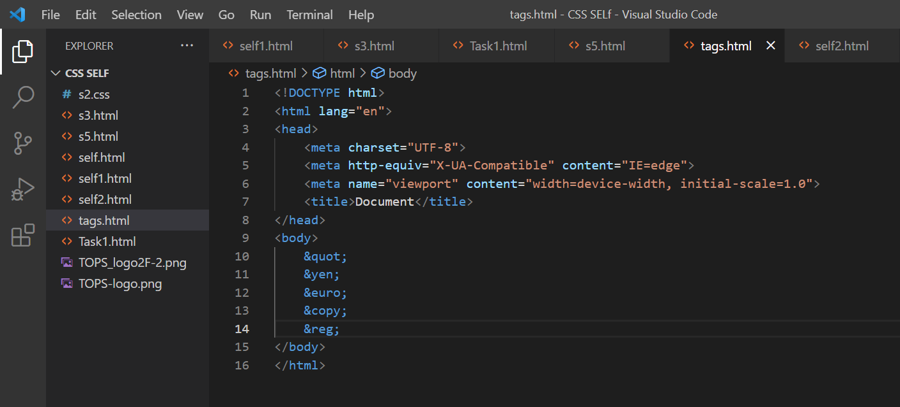

1. What are different types of lists in HTML?

* There are three types of lists. Order list , Unorder list , Data list.

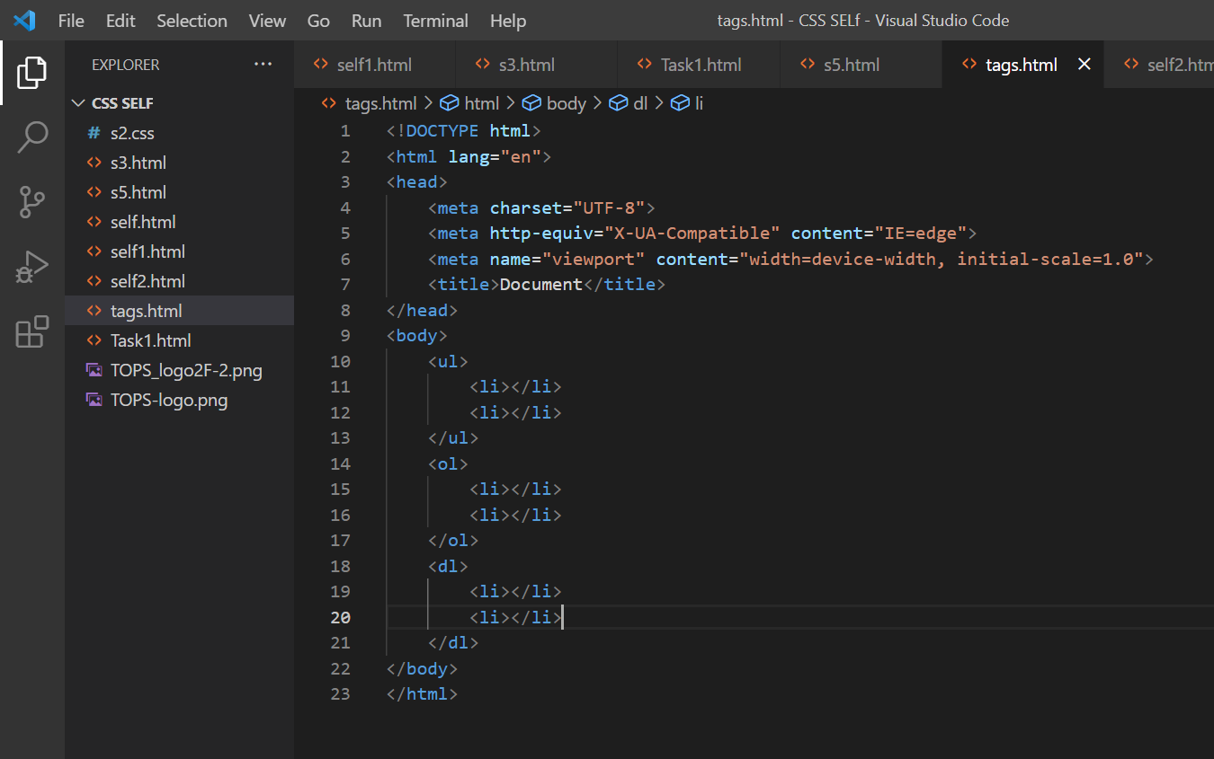

1. What is the ‘class’ attribute in HTML?

* The class is an attribute that specifies one or more class names for an HTML element.

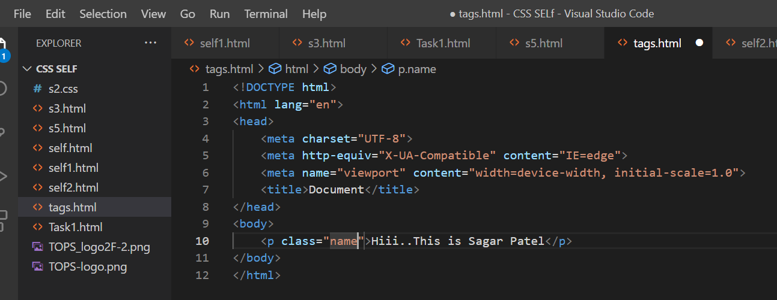

1. What is the difference between the ‘id’ attribute and the ‘class’ attribute of HTML elements?

* A Class name can be used by multiple HTML elements, while an ID name must only be used by one HTML element within the page.

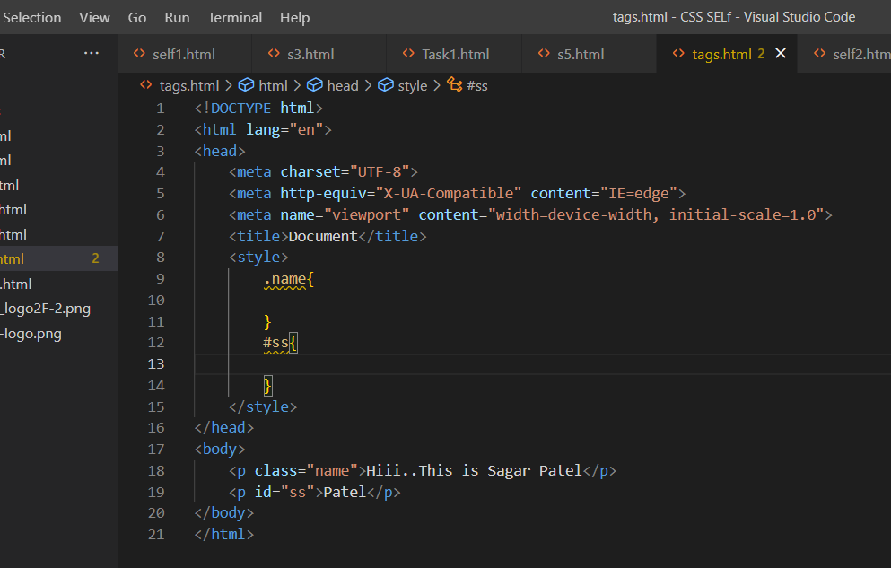

1. What are the various formatting tags in HTML?

* <b> - Bold text , <strong> - Important text. , <i> - Italic text ,<em> - Emphasized text. , <mark> - Marked text.

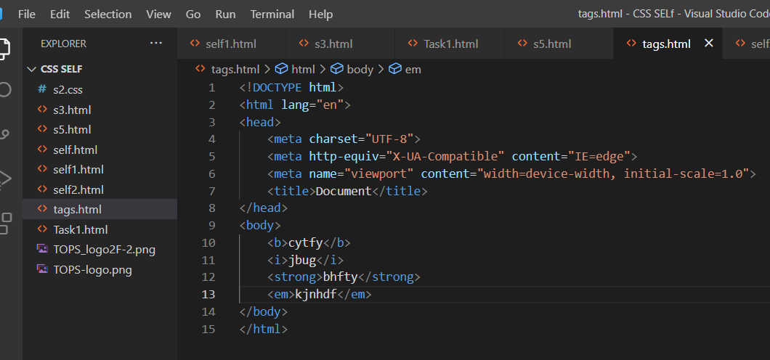

1. How is Cell Padding different from Cell Spacing?

* Cellpadding basically defines the space present between a table cell's border and the content present in it. Cellspacing basically defines the space present between individual adjacent cells.

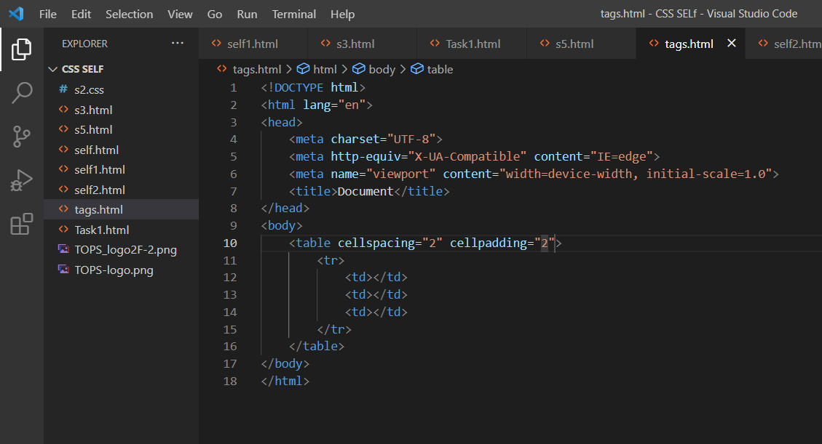

1. How can we club two or more rows or columns into a single row or column in an HTML table?

* You can merge two or more table cells in a column using the colspan attribute in a <td> HTML tag (table data). To merge two or more row cells, use the rowspan attribute.

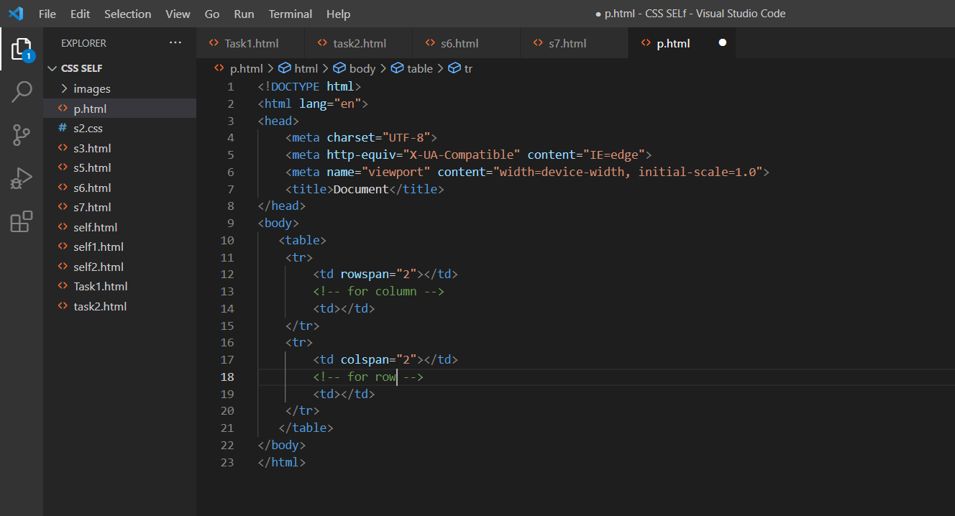

1. What is the difference between a block-level element and an inline element?

* Block elements always start from a new line. Inline elements never start from a new line. Block elements cover space from left to right as far as it can go. Inline elements only cover the space as bounded by the tags in the HTML element.

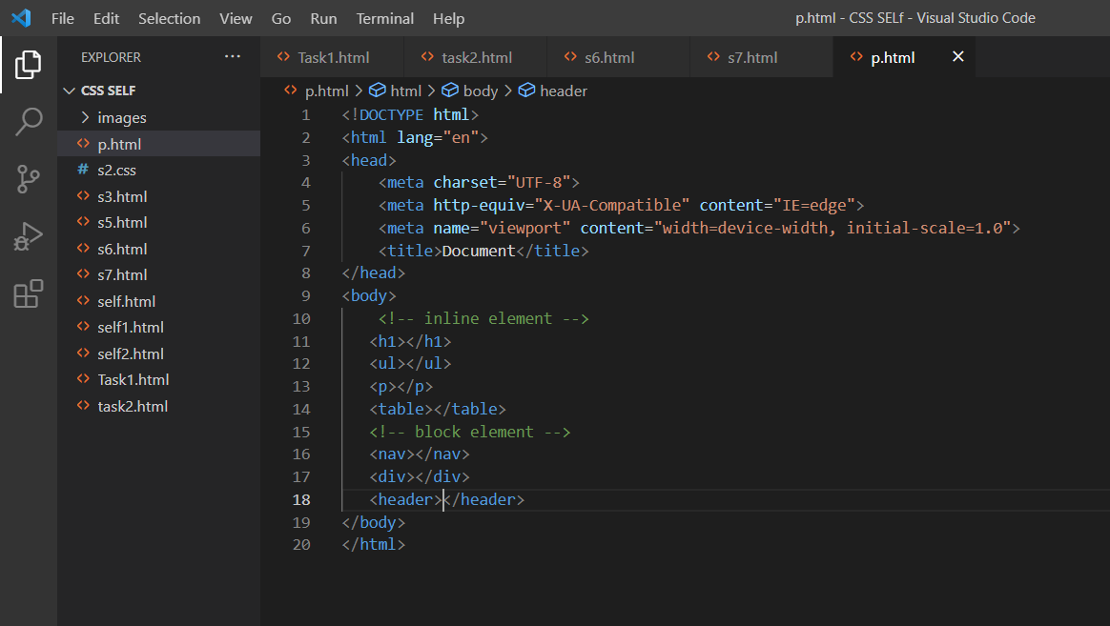

1. How to create a Hyperlink in HTML?

* Use the <a> element to define a link.

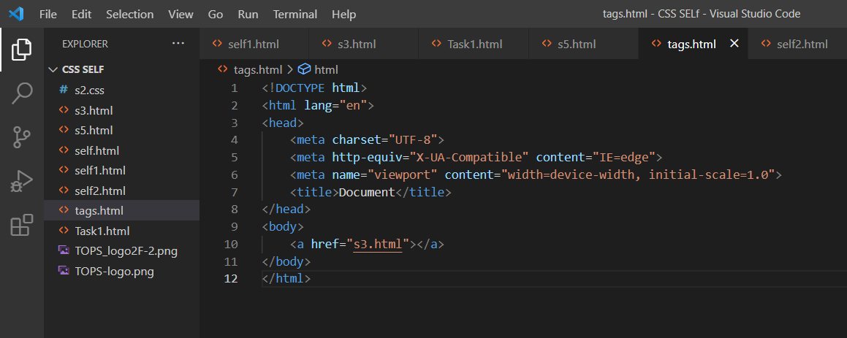

1. What is the use of an iframe tag?

* An iframe element, short for inline frame, is an HTML element that allows an external webpage to be embedded in an HTML document.

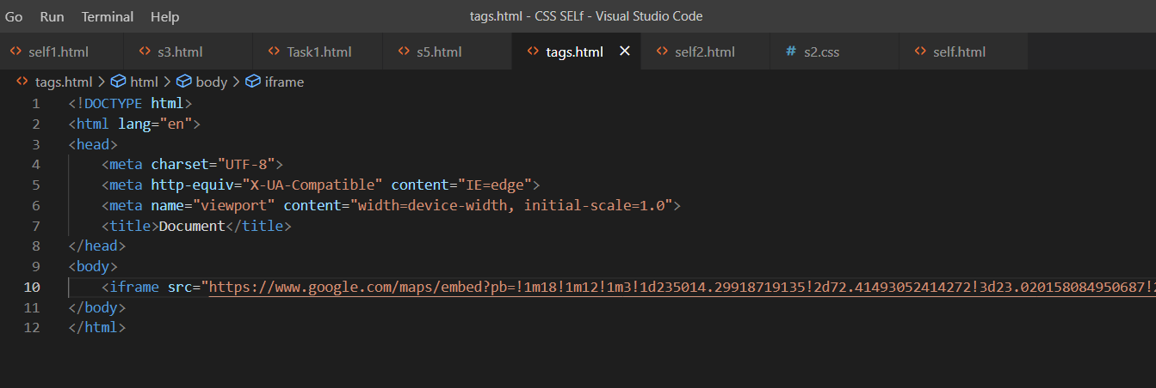

1. What is the use of a span tag? Explain with example?

* The <span> tag is an inline container used to mark up a part of a text, or a part of a document.

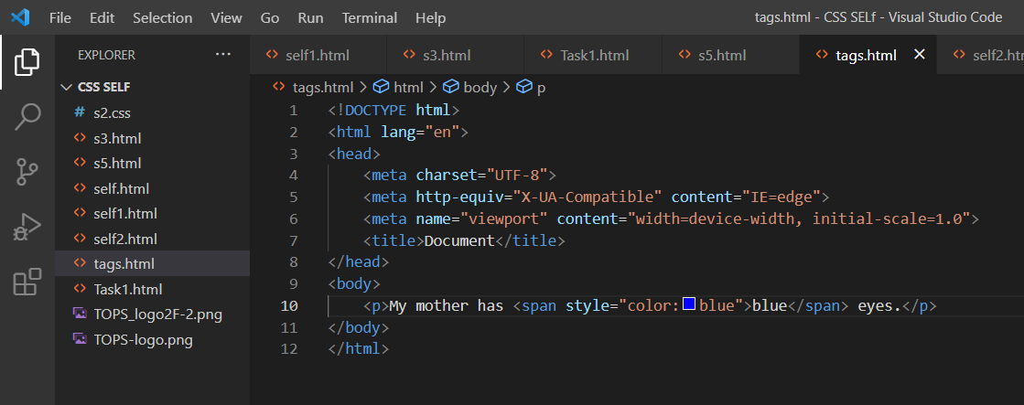

1. How to insert a picture into a background image of a web page?

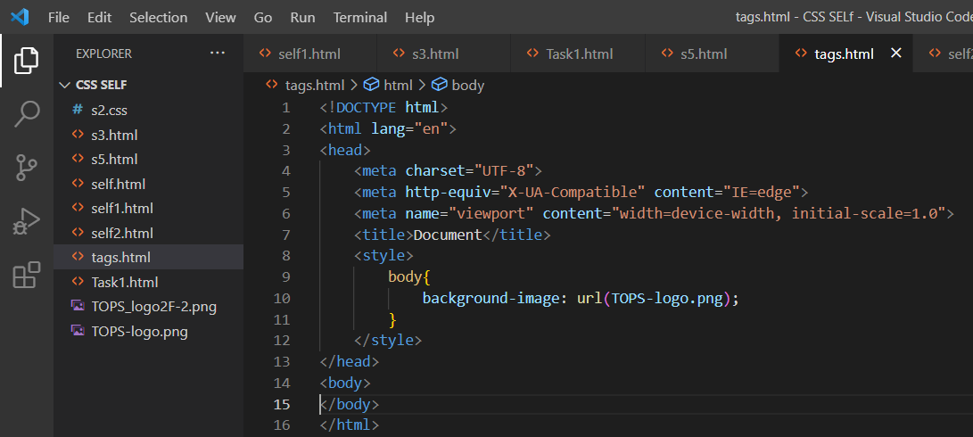

1. How are active links different from normal links?

* An active link is underlined and red.

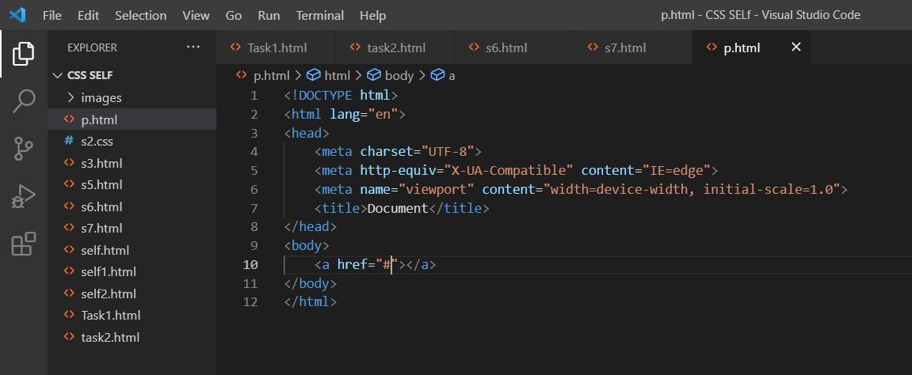

1. What are the different tags to separate sections of text?

* <br> tag – It is used to separate the line of text. It breaks the current line and shifts the flow of the text to a new line. <p> tag–This tag is used to write a paragraph of text.

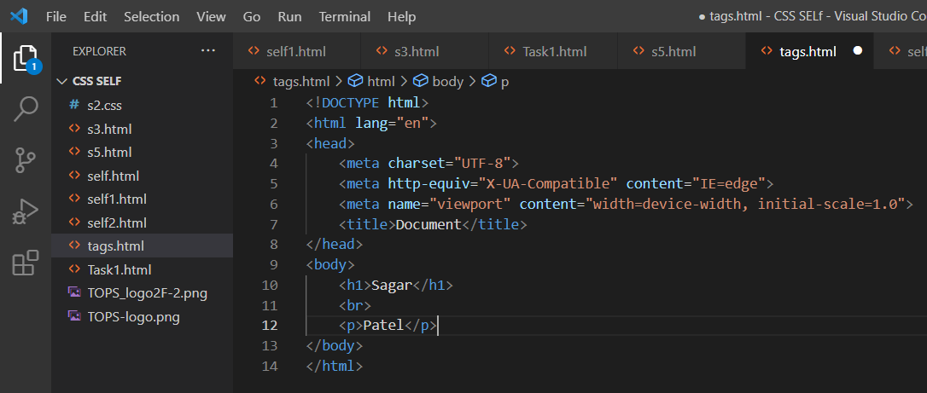

1. What is SVG?

* SVG stands for Scalable Vector Graphics. SVG is used to define graphics for the Web.

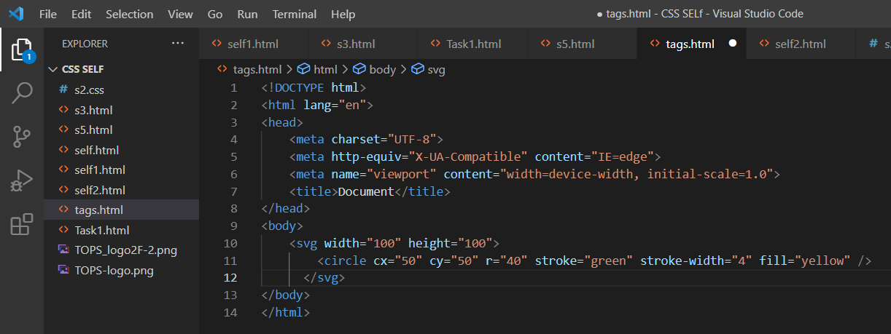

1. What is difference between HTML and XHTML?

* HTML is the standard markup language for creating web pages, while XHTML is a stricter and more standardized version of HTML. Both HTML and XHTML include a wide range of features, such as support for multimedia, styling, and scripting

1. What are logical and physical tags in HTML?

* The example of the logical tag is <strong> </strong> tag. When we enclose the text in the strong tag, it tells the browser that enclosed text is more important than other texts. Physical tags : Physical tags are used to tell the browser how to display the text enclosed in the physical tag.